Independent Water Adoption Panel
Water UK
36 Broadway
London
SW1H 0BH
29th October 2021
F.A.O. Michael Deakin
Ofwat
Centre City Tower
7 Hill Street
Birmingham
B5 4UA
By email only to Michael.Deakin@ofwat.gov.uk

Dear Michael
Independent Water Adoption Panel (‘the Panel’)
Change proposal by Southern Water: Change of LOS Metric S2/2B from a stop/start “chess clock” metric
I write further to the above and to the Change Proposal (‘the Proposal’) submitted to the Panel by Southern Water and published on the Panel’s website on 29 June 2021.
The Panel has now considered the Proposal and I have set out below the details of the Proposal, the Panel’s process for consideration of it, and finally the Panel’s recommendation to Ofwat on the proposal.
I enclose a copy of the Proposal with this letter as an appendix and for ease of reference.
Please note that as there is a representative from Southern Water on the Panel, a declaration of interest in the Proposal was made at the meeting where it was discussed and the Southern Water representative withdrew from the meeting while the Panel discussed its decision on the Proposal.
The Proposal
In the Change Proposal form submitted to the Panel, Southern Water requested that a change be made to the Water Main Adoption Metric S2/2B (excerpt from Water UK LOS Guidance), which currently reads as follows:
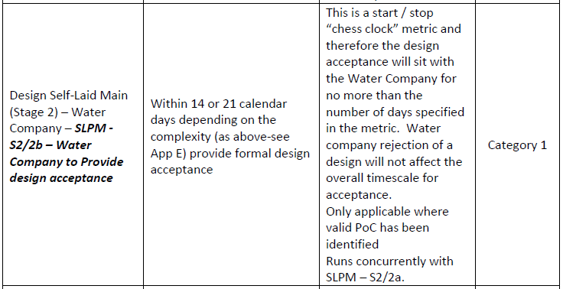

Southern Water proposed that ‘Water Main Adoption Metric S2/2B is changed from a stop/start “chess clock” metric to a restart metric. This would be applicable where a design is non-compliant…..Where a design is non-compliant, the redesign should be subject to the full LOS timescale. This allows the water company time to make the necessary assessment of the amended design, but also encourages the customer to ensure that the design is compliant with the DCS in the first instance.’
In support of the Proposal, Southern Water stated that ‘the ‘chess clock’ approach poses a serious risk to the quality of the review undertaken by the Water Company of a redesign. For example, if a customer was to resubmit a redesign on day 20 of a 21 day timescale for a complex design, the Water Company is left with 2 days to complete a detailed assessment and provide a response, or alternatively miss the deadline. And these 2 days could be a weekend, therefore this is not viable even at a practical level. We believe that this creates the risk of the Water Company rushing their assessment to meet the deadline, and in doing so approving designs that are not fully compliant with the DCS; this can have implications on water quality, water pressure, asset life cycle, the health and safety of staff inspecting and adopting the main etc. ‘

The Panel’s consideration of the Proposal
The Panel considered the Proposal at meetings on 27 July 2021 and 12 October 2021. As Southern Water was unavailable to attend the first meeting to discuss the proposal, the Panel decided that it required further information in order to fully consider the Proposal. On 22 September 2021, Ofwat confirmed that it would extend the deadline as requested for the Panel to provide its recommendation on the Proposal until 31 October 2021.

In considering the Proposal, the Panel has:
- discussed the Proposal at two meetings
- listened to representations from Southern Water at its meeting on 12 October 2021
- submitted the proposal to the Water UK Levels of Service Sub-Group for comment – none were received.

The minutes of the Panel’s meetings when the proposal was discussed are also enclosed as appendices; as are follow-up emails submitted by Southern Water following the meeting on 12th October.

The Panel’s recommendation to Ofwat

In accordance with its Terms of Reference, the Panel has assessed the Change Proposal in terms of:
(a) the need for the change, for example, is it a service improvement or is it needed to address a particular issue;
(b) consistency with the principles and objectives of the Code, and any relevant statutory or regulatory requirements; and
(c) the impact of the change (be it positive and/or negative) on Customers and on Sewerage Companies.

In reaching its decision, the Panel has taken into account the following issues:

- While the design issue has been problematic for Southern Water, it does not appear to be widespread across other the water companies represented on the Panel. Similarly, the developer and self-lay provider members did not consider the issue to be on a large scale. The problem therefore appears to be localised and not industry-wide; however, the Panel noted that even individual failures will have an impact on a company’s D-Mex measure.
- A water company has several opportunities to halt a development if it has concerns over asset construction. Even if there has been an issue with the design itself, this can therefore be picked up and rectified while works are ongoing on site or at the connection stage of the project.
- A change to the overall timescales from a ‘stop-start’ to a ‘restart’ clock could result in additional delays for end users. Given the apparent small scale of the issue itself, this would adversely impact customers for little or no benefit.
- There may be opportunities to improve the metric, for instance by limiting the number of redesigns that can be submitted before it is considered to be a new design. However, this was not part of the proposal that has been submitted.

The Panel’s recommendation is that the change proposal should be rejected. This decision reflects the consensus of all members of the Panel following consideration of the proposal at the meeting on 12 October 2021. This recommendation was made on the basis that there is not an obvious need for the change proposed and the proposal itself does not further the principles and objectives of the Code. However, as pointed out above, there may be opportunities to improve the metric concerned, which is something that could be considered by the Water UK Levels of Service Sub-Group further.

I confirm that a copy of this letter has been sent to Southern Water and has also been published on the website.

If you require any further information or if the Panel can assist any further regarding the proposal, please let me know.
Yours sincerely,

Victor Olowe
Chair
Independent Water Adoption Panel

