WATER SECTOR GUIDANCE
CHANGE PROPOSAL FORM
Please complete the form below to submit a change proposal to the Water Adoption Panel.
Name of Proposed Change:
Change of LOS Metric S2/2B from a stop/start “chess clock” metric

Section 1 - Proposed Change

- Please outline the details (including any relevant supporting documentation) of the proposed change.
We propose that the Water Main Adoption Metric S2/2B is changed from a stop/start “chess clock” metric to a restart metric. This would be applicable where a design is non-complaint.

- Has the proposed change been considered previously (including during any prior consultation process)? If so, please provide details.
I understand that this was discussed by the Panel at the Meeting held April 2021.

- Does the proposed change need to be considered by a specific date? If so, please explain why?
We propose that the change would be ‘backdated’ to April 1 2021, so the DMEX Performance of Water Companies is not unreasonably impacted by the current approach to the Metric.

- Does the proposed change raise any health and safety issues? If so, please provide details.
We respectively believe that the proposed change alleviates possible health and safety issues as the current ‘chess clock’ metric poses the risk that redesigns will be reviewed in haste to meet LOS obligations; we cover this in further detail within the document.

- Please provide any further information relevant to the change proposal.
By way of examples, we had two applications that failed the LOS Metric in May, for the first application we received 3 redesigns and for the second application we received 4 redesigns, this is despite us publicising the DCS on a new SLP web page and including a design considerations document. It is not plausible for a design to be assessed 3 or 4 times within 14 calendar days.

Ironically we have reimbursed the customers their application fee for missing the LOS deadline, therefore we have been penalised for ensuring the design meets with the DCS, both on DMEX and financially. The customers have received their applications fees, despite repeatedly sending in non-compliance designs.

Section 2 - Scope of the Proposed Change
- Which section(s) of the Water Sector Guidance and Model Adoption Agreement does the proposed change concern? Please provide specific references to the relevant documentation.
Water Main Adoption Metric S2/2B (excerpt from Water UK LOS Guidance below)
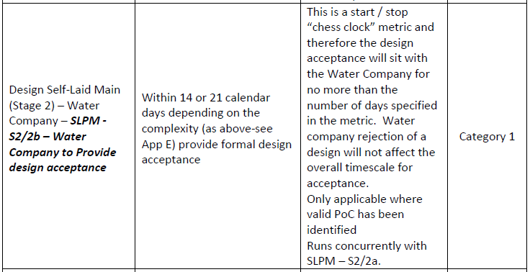

- What consequential amendments to the Water Sector Guidance and Model Adoption Agreement would be required as a result of the proposed change? Please provide specific references.

Water Main Adoption Metric S2/2B would need to be updated to reflect a ‘restart’ Metric when a design is non-compliant i.e. any amended design is subject to the full timescale of the Metric.

Section 3 - Rationale for the proposed change

- What is the nature and effect of the current position/existing arrangements?

For a new design application the guidance is clear on the timescales to provide design acceptance i.e. 14 days (non-complex) and 21 days (complex).

However for redesigns there are no defined timescales, other than what time is left when the ‘chess clock’ was stopped due to the original design being non-compliant.

This creates the risk that assessments of redesigns will be undertaken quickly and without due diligence in order to meet the LOS timeframe, or alternatively the Water Company takes the necessary time and in doing so misses the LOS.

Equally there is no guidance as to what constitutes Minor or Major amendments to a customer submitted design, both these scenarios are currently subject to the same ‘chess clock’ approach, so a Water Company could be left with a couple of days to assess Major amendments to the original design.

- What is the nature and effect of the proposed change?
We propose that where a design is non-compliant, the redesign should be subject to the full LOS timescale.

This allows the water company time to make the necessary assessment of the amended design, but also encourages the customer to ensure that the design is compliant with the DCS in the first instance.

- Why is the proposed change necessary?
We propose that this ‘chess clock’ approach poses a serious risk to the quality of the review undertaken by the Water Company of a redesign.

For example if a customer was to resubmit a redesign on day 20 of a 21 day timescale for a complex design, the Water Company is left with 2 days to complete a detailed assessment and provide a response, or alternatively miss the deadline. And these 2 days could be a weekend, therefore this is not viable even at a practical level.

We believe that this creates the risk of the Water Company rushing their assessment to meet the deadline, and in doing so approving designs that are not fully compliant with the DCS; this can have implications on water quality, water pressure, asset life cycle, the health and safety of staff inspecting and adopting the main etc.

It also increases the likelihood that designs that are not compliant with the DCS will be submitted by customers in the first instance, with the added context that should a Water Company miss the deadline, they are to reimburse the customer their application fee. This could be viewed as rewarding a customer for not complying with the DCS and penalising the Water Company for trying to ensure that the design is compliant.

Furthermore, where a Water Company asks for amendments to ensure compliance with the DCS, the redesign can come back with these amendments, but also new additions to the design. Therefore the Water Company is to assess new aspects of the design that were not in the original, within a reduced timeframe.

The ‘chess clock’ approach also means that Water Companies cannot be assessed comparatively for this Metric under LOS. For example if one Water Company took 10 days to make an assessment of a design and advised it was non-compliant and another Water Company took 12 days, they are left with 4 and 2 days respectively to assess the redesign, this is not a level playing field.
If the view is that assessment should be undertaken quicker than 12 days, then this calls into question the credibility of the 14 day timescale in the first instance. A redesign should not be a consideration in the 14 day timescale, however the ‘chess clock’ approach makes it a consideration.

- What is the desired outcome of the proposed change?
That designs submitted by customers meet with the DCS first time, and that where that does not occur, the Water Company is giving sufficient time to undertake an assessment of the redesign. This timescale should be defined rather than a variable according to when the non-compliance was provided.
Section 4 – Impact on the Principles and Objectives of the Code

- Outline, how and why the proposed change maintains consistency with the principles and objectives of the Code for Adoption Agreements, and any relevant statutory or regulatory requirements?
One of the principles of the code is to create a level playing field that allows customers so to operate in a similar fashion to Water Companies. By allowing customers to submit non-compliant redesigns indefinitely within a 14 LOS calendar window, and then penalising the Water Company for trying to ensure they become complaint, we are not setting a level playing field. We are also not working within the spirit of the code in striving for compliant designs and work that meets with the DCS, we are promoting the opposite by rewarding customers who submit non-compliant designs through reimbursing their application fees.

Section 5 – Impact on Customers and Water Companies

- What is the impact of the proposed change (be it positive and/or negative) on Customers?
Customers will be required to endeavour to ensure that their original design meets with the DCS. Where it does not, their application will restart in regards to the timescales once a redesign is submitted. Customers may perceive this negatively, however the positive is that they will become more familiar with the DCS and what is expected for a compliant design.
Customers will also have a clearly defined timescale for an assessment of a redesign.

- Is there any evidence of customer concern relating to the proposed change? If so, please provide details.
No evidence, however they are not aware of this proposal.

- What is the impact of the proposed change (be it positive and/or negative) on Water Companies?
Water Companies will have the necessary time to assess a redesign, ensuring that there is no risk posed by the design to water quality, water pressure, asset life cycle, the health and safety of staff inspecting and adopting the main etc.
They will also not have to reimburse an application fee where a customer has not been compliant with the DCS.
The Water Company will also not be penalised on DMEX for trying to ensure compliance to the DCS.

- Estimate how much notice Customers and Water Companies may reasonably require to be able to meet any new requirements arising from the proposed change.
We propose that this change can be implemented with a months’ notice and that the DMEX calculation should be subject to the change as of 1 April.

- What is the suggested implementation date of the proposed change?
1 August 2021 for implementation, with the DMEX recalculation for Water Companies where required ‘backdated’ to 1 April.

Section 6 – Stakeholder Engagement

- Please outline any informal/formal consultation undertaken with relevant stakeholders likely to be affected by the proposed change, including details of any responses provided by stakeholders.
There was initial engagement with the LOS Working Group, who advised that they would wait and assess performance against the Metric, we advise that may not be prudent approach as Water Companies may be rushing assessments of redesigns to meet the LOS, in which case the risks are not visible, or alternatively miss the LOS, in which case their performance has suffered from undertaking the necessary assessments.

The LOS Working Group referred us to the Code Panel.
Section 7 – Applicant’s Details
Name: Ryan Lownds – Service Delivery Lead
Company: Southern Water
Company Registration Number:
Company Address:
Telephone: 07827 898856
Email: ryan.lownds@southernwater.co.uk

